Engaging Students Online: A Panel Discussion with School of Business Course Developers

Additional Notes and Resources:

Creating Effective Video Lectures…………………………………………….……. 2-4
Assessments and Strategies to Prevent Cheating………………………………. 5
Managing Online Group Projects…………………………………………………… 6-7
Discussion Board Tips and Best Practices……………………………………….. 8-10
Utilizing Outside Resources to Enhance your Classroom……………………… 11-12

Laura J. D’Antonio, Assistant Professor, Foundations – Creating Effective Video Lectures

Video can be used effectively both in the online classroom and to supplement in-seat or hybrid classes. Video can aid depth of understanding, clarify material, and illustrate concept relevance (Mateer, 2011). However, since creating and uploading video can be a labor-intensive experience for the instructor (an average of two hours of prep for a 15-minute video clip), making sure the video will actually be watched and will promote learning is key. Here are a few things to think about:

Video Purpose
Video resources can be loosely classified into two types – lecture (content delivery) and tutorial (working of problems, reviewing material, etc.). Instructors should think about the purpose of the video first and change the structure accordingly. Common uses for online video include: chapter or unit introduction, explanation of a difficult topic, connecting the text to student understanding, problem-working, and providing feedback (DiPaolo et al. 2017). Once the purpose has been determined, an appropriate format can be selected. For example, for a tutorial video (i.e. working problems), a Khan-style video (a hand writing on a board) might be best while a lecture video might be better using a talking-head style format for introducing or explaining a difficult concept. Adding section stops or including minute markers might make it easier for students to go back and review selected sections.

Length
The “transmissive” type of video (delivering information lecture-style) tends to have limited engagement and effectiveness if it is too long. One study (Guo et al., 2014) showed that the average student watch-time is a mere six minutes regardless of the overall length of the video. Keeping this in mind, video content should be front-loaded. If students are only going to watch the first six minutes, that’s where the bulk of the content should be. Common guidance in the literature is to break content into 15-20 minute or shorter video chunks – the shorter the better.

Recording an in-class lecture and posting it in its complete form is not recommended for creating effective online lectures. Not only are these sessions most likely longer than 15 minutes, students may have the feeling they are “listening in” on a session that did not include them. The attention of the speaker is on the students in the actual classroom as opposed to the students in the online classroom.

Style
There are many style options available for video recordings. Studies (e.g. Thompson et al., 2014) have suggested that high production-value video is not necessarily better and in fact a more casual style, low budge production is often preferred by students. “Fit-for-purpose” quality is usually plenty. Using a laptop camera and microphone plus available light is generally preferable though all video should be recorded in a quiet space and tested for good-quality sound.

Style also includes visual options of slides only, text versus images, instructor-image included (either picture-in-picture or inserted head shots), screen sharing, write-on slides (Khan-style), and many others. Though the optimal choice will depend on the content and topic, a few general guidelines have emerged from the literature. Whether instructors are comfortable on camera or not, students prefer to see the instructor (Guo et al., 2014) though the instructor should not necessarily be standing and lecturing. Including either head shots periodically in the slides, or as a talking-head presence in the corner, having instructor visibility increases student engagement and has the added benefit of increasing social presence in the course (Di Paolo et al., 2017).

Images are preferred over text. Not only is a picture worth a thousand words, images retain interest while encouraging students to take notes. The redundancy of text on the slides which is then repeated by the lecturer, has actually been shown to reduce comprehension (Koumi, 2006). Other than a few key cueing words, presenters should use imagery to tell the story.

Assessment Integration
Integrating assessments that directly relate to the video lecture content can help with engagement and learning (Gou et al., 2014). One option is to embed quiz questions directly into the lecture especially after making key points. There are now several software package to facilitate this process. Embedded questions should be low stakes or ungraded assessments meant to engage students by giving them something to do while enabling them to self-assess their learning. Embedded quizzes have the added benefit of allowing instructors to monitor how much time each student spends watching the video.

Quiz questions can be embedded directly into the video or a low stakes assessment quiz can immediately follow the video which may be an easier strategy for including results in the gradebook. Storyline is a software package that creates effective post-lecture assessments. Other linked assessment strategies include having quiz questions, activities or discussion forum questions that relate directly to material covered only in the video lecture. Finally, giving students a worksheet to complete while watching the video lecture which they then post and are graded on (low stakes) acts as another way of engaging students with the recorded lecture.

Presenter Style
Similar to an engaging lecture in the classroom, presenter style has much to do with an creating an engaging video. In an effective and engaging video, the personality and presence of the presenter are evident throughout the video. Including picture in picture in the recording strategy can help create presence. The video should not feel overly scripted or read. Presenters need to be conscious of their pace. Studies (e.g. Guo et al., 2014) have shown that students are more engaged in videos where the presenter speaks fairly quickly and the presentation moves at a reasonably rapid pace. Camera positioning also plays a role in effective video creation. Presenters should make eye contact through the camera to their students (again assuming students have some visual representation of the instructor in the video).

Other Considerations
There are many software packages to help with creating engaging video lectures. Kaltura has the advantage of being very easy to record on a laptop, and easy to download into Blackboard. Camista and Snagit are two other available software packages. PlayPosit allows questions to be embedded in videos as does Kaltura and Zaption allows presenters to embed a survey into a video.

Administrative details (anything specific to the class itself, references to the school, etc.) should be kept out of the video. Content that is more general has a longer “shelf-life” and may travel with you if you leave the school.

References

Di Paolo, T., Wakefield, J.S. & Mills, L.A. (2017). Lights, camera, action: Facilitating the design and production of effective instructional videos. TechTrends 61: 452. https://doi-org.mutex.gmu.edu/10.1007/s11528-017-0206-0

Guo, P. J., Kim, J., & Rubin, R. (2014). How video production affects student engagement: An empirical study of MOOC videos. Proceedings of Learning @Scale 2014, March 4-5 in Atlanta.
Association for Computer Machinery (pp. 41–50). ACM 978-1-4503-2669-8/14/03. doi:10.1145/2556325.2566239.

Koumi, J. (2006). Designing video and multimedia for open and flexible learning.
Oxford, UK: Routledge Falmer.

Mateer, G. (2011). Using media to enhance teaching and learning. Starting Point:
Teaching and Learning Economics. Retrieved from http://serc.carleton.edu/econ/media/index.html

Thomson, A., Bridgestock, R., Willems, C. (2014). ‘Teachers flipping out’ beyond the online lecture: Maximising the educational potential of video. Journal of Learning Design, [S.l.], v. 7, n. 3, p. 67-78. doi:http://dx.doi.org/10.5204/jld.v7i3.209

Yvonne Demory, Assistant Professor of Business Legal Studies - Assessments and Strategies to Prevent Cheating
- Use online proctoring or test centers, if available.
- Use a big pool of test questions and randomize questions for each student.
- Time the assessment, giving just enough time.
- Require that students finish the assessment once it is opened, no saving and continuing later.
- No multiple attempts.
- Write your own test and essay questions; the more specific the better (but not so specific that students will try to look up the answer on the Internet). Hypotheticals may be best, depending on subject area.
- One strategy some use is to release entire test bank and essay bank to students.
- Use SafeAssign or similar plagiarism check for writing assignments.
- Provide instructions and warnings about cheating in multiple places on Blackboard, including in the assignment itself.
- Track students who are retaking the course, send them an email at beginning of semester about not resubmitting any assignment or part of an assignment again (even if you change assignment questions, students still try to resubmit previous work). Closely monitor their written work over the semester. Self-plagiarism violates the GMU Honor Code.

- Examples of instructions:
  - Your response must be your own original work; you may rely only on the material available in the course (textbook or e-book, lectures, slides) for your essay response. Do not quote from any material; paraphrase in your own words. Do not consult the Internet during completion of the essay.
  - Do not use the Internet as a resource. Do not cheat (includes using unauthorized resources and/or collaborating with others), plagiarize or self-plagiarize (from an assignment submitted in a previous semester of this course or any other course). Essays are subject to submission to Safe Assign. Violations of these rules will result in scores of 0 and referral to the Honor Committee.
  - Please remember: do not collaborate, use Internet resources or cut and paste from any source, including the TEXTBOOK. Show your own understanding, application and analysis. Responses are subject to SafeAssign check.

James W. Harvey, Associate Professor, Marketing – Managing Online Group Projects

The overarching issue is the “no difference” hypothesis in distance learning (Zhao 2005). A related crucial question is how best to implement group work on line.

Chapman, et al (2010) provides a reminder that ability to work with a group is one of the most important attributes for hiring business school graduates.

Interestingly, these researchers found faculty have a significantly more pessimistic perception of student group dynamics and outcomes on 13 of 16 measures reported in their study. Compared to students, faculty felt that student groups had more arguments, had poorer communication, were less enthusiastic about working together, were less likely to follow through on commitments, didn’t use time well during meetings, took less pride in their work, and possessed more members who didn’t do their fair share of the work.

Group projects in online courses have the potential for engaging students in collaborative work to learn new content and prepare them for career success. Harvey, et al (2012a; 2012b; 2012c; 2014a; 2014b) found that students who collaborated with others outside of the classroom for online components of a business course reported enjoying it more and learning more.

Lowes (2014) noted that online group projects are still a work in progress in terms of how best to structure, facilitate, and assess results. Five key guidelines for structuring successful online group activities are identified in her work:
- Each group member’s efforts must be required and indispensable for group success and each group member must have a unique contribution to make
- Collaboration must be facilitated by the use of collaborative spaces, such as with Google Presentations, Collaborate Ultra and others.
- Students need very clear instructions as to what collaboration should look like.
- Students need to know what “good talk” and cooperative interaction look like in the online environment.
- Students need to allow sufficient time to collaborate and instructors need to incorporate an expanded timeframe into the group activity.
Here are key points from these perspectives for discussion:

- How to address faculty skepticism of the value of group work?
- How to address five elements to insure student success in group settings
  - How to assure each group member has a unique online contribution to make
  - What’s the best way to facilitate online collaborative spaces? By direction or let groups make their own selection?
  - What does successful online collaboration look like?
  - How is online "good talk" and cooperative interaction modeled and mentored?
  - How is “sufficient time to collaborate” operationalized?

References and Resources

Chapman, Kenneth J. et al (2010) “Are Student Groups Dysfunctional? Perspectives from Both Sides of the Classroom” Journal of Marketing Education, Vol 32 No 1, pp. 39-49.

Dixson, Marcia D. (2010) “Creating effective student engagement in online courses: What do students find engaging?” Journal of the Scholarship of Teaching and Learning, Vol. 10, No. 2, pp. 1 – 13.

Draper Darryl C. (2015) “Collaborative Instructional Strategies to Enhance Knowledge Convergence,” American Journal of Distance Education, 29:2, pp. 109-125, https://doi.org/10.1080/08923647.2015.1023610

Harvey, J. W., McCrohan, K. F., Kulick, J., & Philpot, F. A. (2012a). “The Effects of Peer Collaboration on Student Evaluations of Distance Education in Marketing.” In Kevin J. Shanahan (Ed.) Society for Marketing Advances, 1, Annals of the Society for Marketing Advances, 196 - 200. http://c.ymcdn.com/sites/www.marketingadvances.org/resource/resmgr/imported/2012%20Conference%20Proceedings.pdf

Harvey, James W. et al, (2012b), “The Impact of Hybrid Distance Learning on Student Performance.” American Institute of Higher Education 7th International Conference Proceedings, Williamsburg, Virginia.

Harvey, J. W., McCrohan, K. F., Philpot, F. A., & Kulick, J. (2012c). “The Impact of Hybrid Distance Learning on Student Performance.” In Alireza Lari, Wake Forest University (Ed.) American Institute of Higher Education 7th International Conference Proceedings, 5 (1), Williamsburg, VA: American Institute of Higher Education, 168-180. http://www.amhighed.com/williamsburg2012/documents/aihe_proceedings.pdf

Harvey James W. et al, (2014a), “Impact of Student Collaboration on Classroom Satisfaction and Learning” NMC Horizon Report: 2014 Higher Education Edition, p. 11.

Harvey, J. W. (2014b) EDUCAUSE Learning Initiative Webinar March 12, 2014. http://events.educause.edu/ir/library/pdf/LIVE1405_Harvey.pdf
Lowes, Susan (2014) “How Much ‘Group’ is there in Online Group Work?” Journal of Asynchronous Learning Networks Vol 18, No 1, pp. 133–146.

“The 2014 Horizon Report EDUCAUSE Learning Initiative” Malcolm Brown and Veronica Diaz (moderators). EDUCAUSE Learning Initiative. http://events.educause.edu/educause-live/webinars/2014/educause-live--the-horizon-report-in-action. March 12, 2014.
Zhao, Yong, Jing Lei, Bo Yan, Chun Lai and Sophia Tan (2005), “What Makes the Difference? A Practical Analysis of Research on the Effectiveness of Distance Education,” Teachers College Record, 107(8), 1836–1884.

Cindy Parker, Assistant Professor, Management - Discussion Board Tips and Best Practices
Discussion Question Techniques:
- To begin building collaboration, the first Discussion Board of the course could be an “introductory post” where students share information about themselves. Ask students to share their educational and professional background, a “fun fact,” and picture of themselves (if they are comfortable doing so). Encourage interaction by asking each student to read all introductory posts and comment on the post of at least “X” number of students.
- The number of questions asked per week should depend (in part) on the number of other learning activities taking place during the week. One to three discussion questions per week is typical. If there are multiple questions you’d like the class to consider, provide two or three questions and allow students to choose one. You can place limits on the number of students responding to each question (first come, first served – helps eliminate procrastination) to ensure each question is addressed.
- Questions should:
  - involve the week’s reading and/or lecture, if applicable (which motivates the student to do the reading and/or watch the video lecture)
  - allow the student to apply knowledge of core concepts (which helps the student apply their learning in a realistic context), and
  - give the student an opportunity to convey their personal experience or opinion (which will help to ensure that each answer will be different from those of other students). (Velez-Solic, 2015).
- Avoid questions that can be answered with “yes, “no,” or any one-word response, have only one or two correct answers, that don’t involve the course reading/lecture for the week, and that don’t relate to the course learning objectives for the week.
- In large classes (more than 25 students), consider dividing the class into Discussion Groups. Assign each student to a group of 8 – 10 students and create separate discussion threads within a Discussion Board for each group. This technique will help students to navigate through and review the contributions of their peers, and help faculty in their management of the discussion.
- Consider assigning different roles (such as Initiator, Devil’s Advocate, Elaborator, Summarizer) or positions (pro/con) to students for some Discussion Boards.

Planning and Managing Discussions:
- Be explicit with expectations about how many questions to answer and the number of peer replies expected each week.
- Provide a detailed description of what a “quality” post and reply looks like (average number of words or paragraphs), along with a few examples of good and bad posts/replies.
- Use the “post first” technique, which requires students to create a thread in order to view other threads in the forum. This will encourage originality of thought in the initial posts.
- Encourage students to post/respond in a manner that continues a conversation and provides hooks for additional dialogue.
- Instruct students to make an initial post by mid-week, with one or more responses due by the end of the week. This will allow you time for the faculty member to interact and allow students to pace their work.
- Encourage students to incorporate course readings, lectures, or their personal experiences into their posts/responses. Instruct students to provide proper citations if they incorporate any external sources in their posts/responses.
- Remind students to use proper language, spelling, and grammar in their posts/responses (and include this as part of your grading criteria).

Faculty Involvement in Discussions:
- Be visible in the forum by commenting on posts a few times a week – your involvement will help to keep students engaged in the material and the course.
- In week 1, respond to every introductory post – it sets a good starting tone and brings a personal touch to what may feel like an impersonal learning experience.
- When the discussion board is closed, summarize and post the key ideas/takeaways.

Grading Discussions:
- Give the overall discussion board grade appropriate weight in the course, relative to other assessments.
- Create and share a grading rubric for posts and replies (see example on next page).
- Create a “feedback” document tailored to each discussion board, with boilerplate feedback for “exceeds expectations,” “meets expectations,” and “below expectations.” Use this to streamline the feedback you provide students in the gradebook.

References
Velez-Solic, Angela (2015). Teaching Online Without Losing Your Mind: A Comprehensive Overview. AVS Academic Services.
Beottcher, Judith V., & Conrad, Rita-Marie (2016). The Online Teaching Survival Guide, Second edition. Jossey-Bass.

Example of Discussion Board Assignment
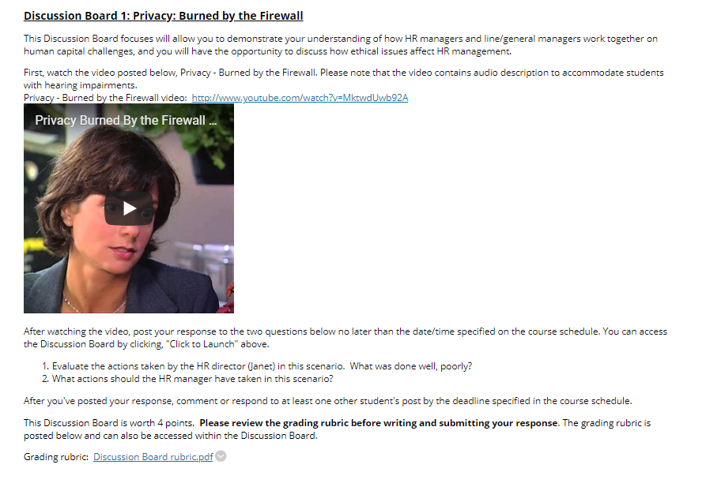
Example of Discussion Board Rubric
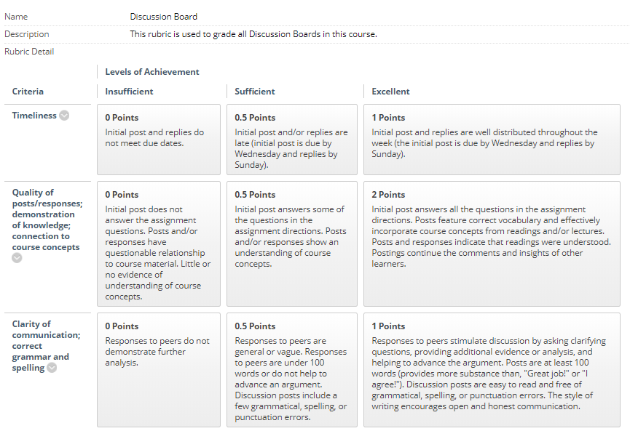
Katherine Rosenbusch, Assistant Professor, Management - Utilizing Outside Resources to Enhance your Classroom
No matter what tool you use in your online classroom it is about student engagement and synergistic learning. The role of the instructor in online learning is connecting the content to bring it to life. In online learning this can be lost if not designed properly. It is important be intentional about the content and the scaffolding of the material. Using outside resources can enhance the learning experience for the student. There are several tools and resources that can be utilized to enrich your course. Below are a few that can be used:
- Blogs (WordPress or Blackboard Blog) A unique way for students to reflect and journal about their learning.
- McGraw Hill Connect provides a platform with activities, case studies, and interactive presentations.
- SmartBook is a digital version of your course textbook. It contains the same content but it tailors the content to your individual needs of the student.
- Cengage Learning MindLinks Building Block provides seamless access to several Cengage digital products, including CourseMate and MindTap, directly within Blackboard Learn.
- Pearson MyLab provides tools and resources to bridge the content in text.
As instructors, it's important for us to understand that there is so much more to students than the life they lead in class, and it is important to show interest in a student and connect the content to their life. These tools can assist to make that connection.
It is a bit of a shift in your paradigm in terms of how you get the same concepts in a face to face class in the online setting. One professor stated "I don't teach definitions anymore. I get right into analysis, news articles, and discuss the things that are exciting!" I let Connect® teach the basics, so I can be the educational expert I trained to be." You can use these integrative tools to foster a dynamic learning environment in the online classroom. Each tool has its pros and cons so figure out which one best suits you as an instructor.
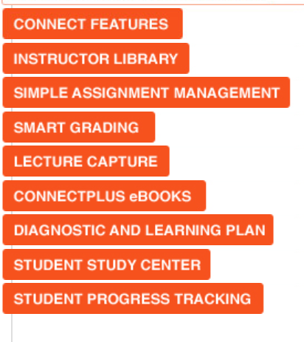
Some pros of using the resources:
- Cases and activities in one place and fully integrated into Blackboard LMS platform.
- Different types of tools for the students to use based on their learning needs
- Ability to capture diagnostics of students that may be struggling in your class.
- Easy of grading for faculty—grades automatically placed into the Blackboard gradebook
- Extends learning beyond the classroom for students

Some cons:
- Technology glitches and it is not perfect
- Sometimes the platforms do not speak to one another and information is lost
- Students have a hard time figuring it out at first—steep learning curve in the beginning of the class
- Some platforms have greater resources than others—do your homework before launching.

Sample of Blackboard Folder with Homework Assignments
Sample of Connect Site with Homework Assignments
